July 29, 2026

To Whom It May Concern:

Concerning Participant

Participant is a citizen residing temporarily in city as a full-time volunteer church participant, sponsored under our Mennonite Voluntary Service program. Participant’s term of service continues until date.

Participants reside together at unit address.

Participant volunteers time and skills at agency as a volunteer without remuneration. Therefore, participant receives no salary, and is supported with a modest room-and-board arrangement provided through our program in partnership with the agency of placement.

Therefore, any discounted rate that you might be able to provide participant for goods or services essential to supporting her time here in city such as groceries, public transportation, etc., would be greatly appreciated.

Thank you for your charitable contribution to the volunteer and humanitarian culture of your city, on participant's behalf.

Blessings
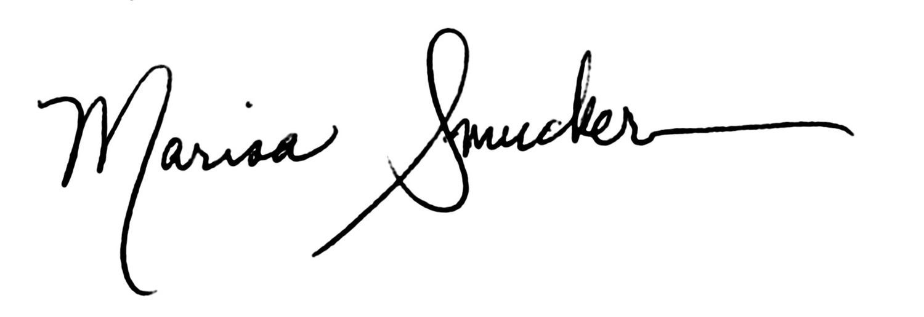
Marisa Smucker
Director
Mennonite Voluntary Service

